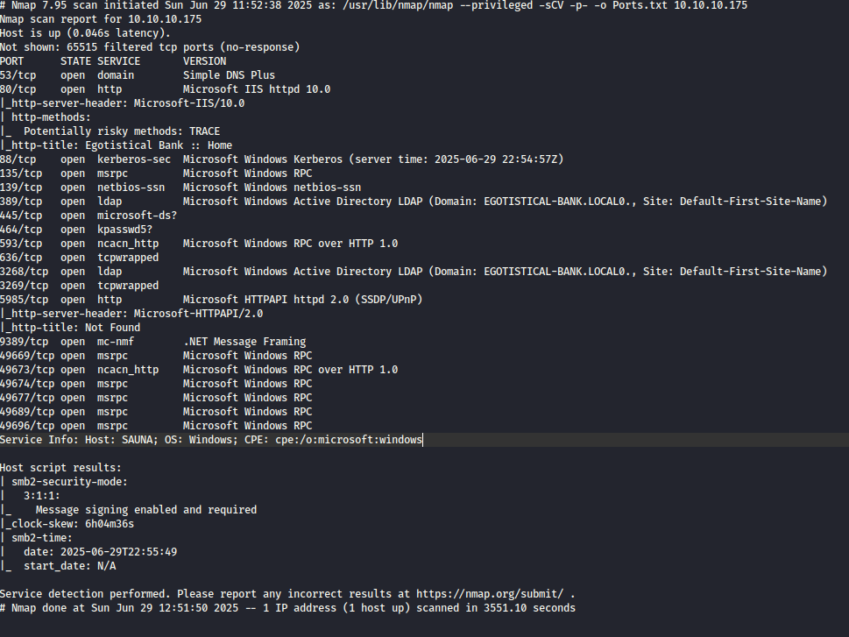

We start with a basic nmap scan which shows us a basic configuration for Active Directory machines and a webapp on port 80 running Microsoft IIS 10.0.
We then use feroxbuster to enumerate directories for potentially enlarging our attack surface.
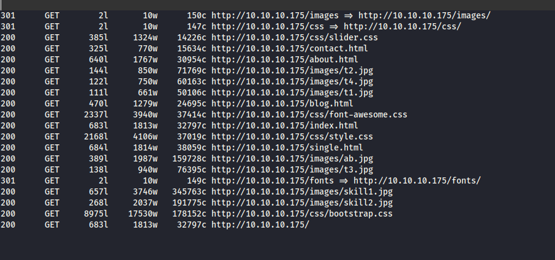

Nothing interesting at first glance but we still go through each one of them.
I couldn’t find anything of interest so I switch my attention to the ldap and smb services running on our machine.
First, I try to connect via smbclient with a null session.
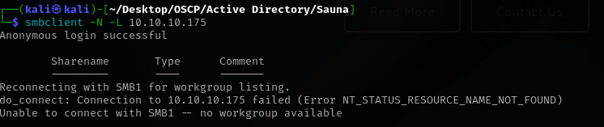
Login successful but nothing listed.
I then switch to crackmapexec.
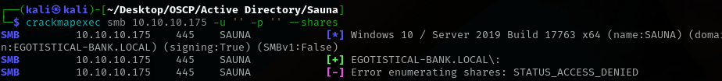
Nothing here either.
So, after using GetNPUser.py and xató top 10 million wordlist and waiting a while, I found and user and password hash
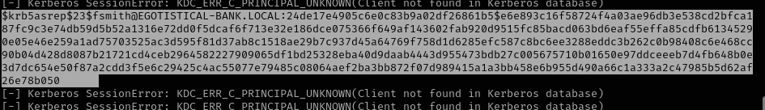
The format of this hash is standard for AS-REP Roasting, and it's compatible with popular password cracking tools like Hashcat and John the Ripper.
Echoing the whole output into a txt file and using hashcat to crack it gave us the password.
Noticing that the Windows Remote Viewer is running on port 5985, I’ve used evil winrim along with the credentials found and got inside.
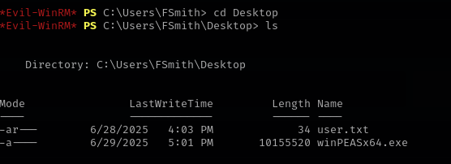
Once inside, we head to Desktop and find the user flag but also winPEAS, a powerful privilege escalation tool.
Running winpeas we find credentials for a more privileged user and we use those to login via evil-winrm
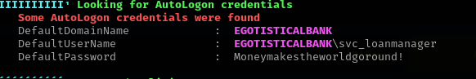
The username is actually svc_loanmgr, as I found out the painfull way.
Once inside we find ourselves as another local user without privileges so I run impacket secretsdump.py
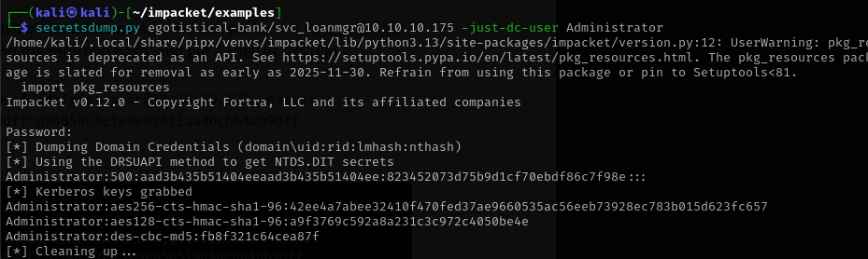
This will reveal all users hashes , then we can perform a pass the hash with psexec.
In order to get the Domain controller I run nltest /dclist:EGOISTICAL-BANK.LOCAL
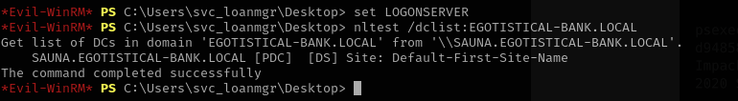
Now we run psexec.py and get inside
